

**Department of** **Computer Science and Engineering**

**CSE 251-Mini Project**

Course Name: Electronic Circuits

Course Code: CSE 251

Section No: 01

**Name of the Project:** Sinusoidal wave (2V p-p, 1kHz) to amplified square wave converter maintaining the same frequency.

**Date of allocation:** April,2022

**Date of submission:** May,2022

**Student’s Name:** Sadia Islam Prova

**Student’s ID**: 2020-3-60-012

**Student’s Name:** Md. Dil Monsur Khan

**Student’s ID**: 2020-3-60-034

**Student’s Name:** Md. Iftekhar Alam Sarker

**Student’s ID**: 2020-3-60-035

**Submitted To:** Touhid Ahmed

Lecturer

Department of Computer Science and Engineering

**Theoretical discussion**:

Here we need to convert the sine wave into an amplified square wave that maintains the same frequency. That is, we need to create an amplified non-inverted square wave. we can convert this waveform by using an operational amplifier. Op amps are linear devices with all the characteristics needed for near-ideal DC amplification and are often used to tune, filter, or perform mathematical operations such as addition, subtraction, integration, and differentiation. The inverting amplifier is an operational amplifier circuit and is configured to generate an amplified output signal, and this output signal of the non-inverting operation amplifier is in phase with the applied input signal. A well-biased non-inverting amplifier can be used to convert a sine wave into an amplified square wave.

**Output saturation:**

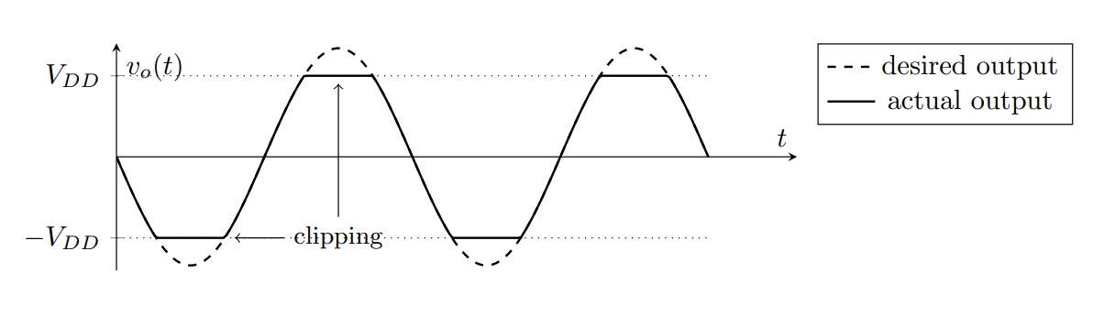Naturally, an op-amp can only output voltages contained within the range of its power supply. (In fact, most op-amps can’t quite hit that range—they stop at about 1 V to 2 V before the power supply voltage, depending on the op-amp and circuit.) When the output voltage implied by the circuit would exceed the possible range, the op-amp is said to saturate, and it just outputs its maximum or minimum possible voltage instead. We often call the supply voltages the rails. When op-amp output saturation causes the signal to be cut off close to the rails, we say that the signal is clipped.

**Figure 1: Output saturation**

Now, we have to design a circuit that will clip the output function and also, we need higher gain to make our function square.

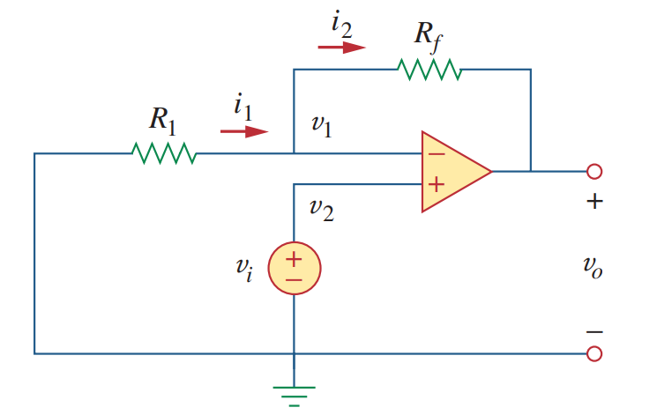**Circuit Diagram:**

**Figure 2: Noninverting Amplifier**

For this circuit we will have this equation,

$$V_{o}=\left(1+\frac{R_{f}}{R_{1}}\right)×V_{i}$$

From this equation, our gain will not be less then 1. But we need higher gain. So, we will take **Rf = 100K Ω** and **R1 = 1k Ω.** Now, our gain will be (1+ 100/1) or, 101 times.

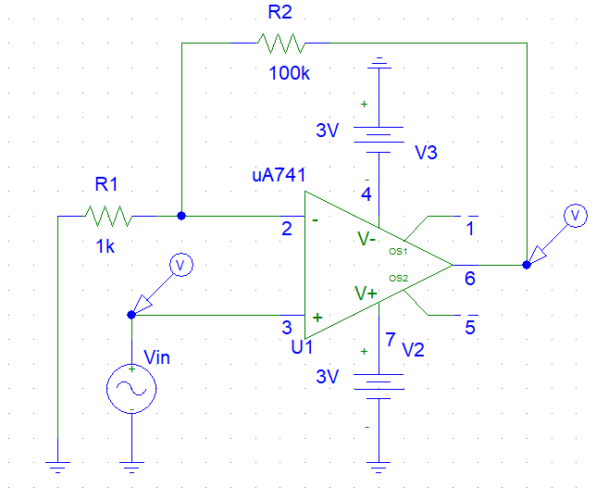

**Figure 3: Circuit design in PSpice.**

This figure circuit will saturate output voltage at 3V. Also, this circuit has higher gain. After simulating this circuit this will show a square function for output voltage. Here we set the peak to peak voltage for 2V and the frequency was set to 1K Hz.

**Simulation:**

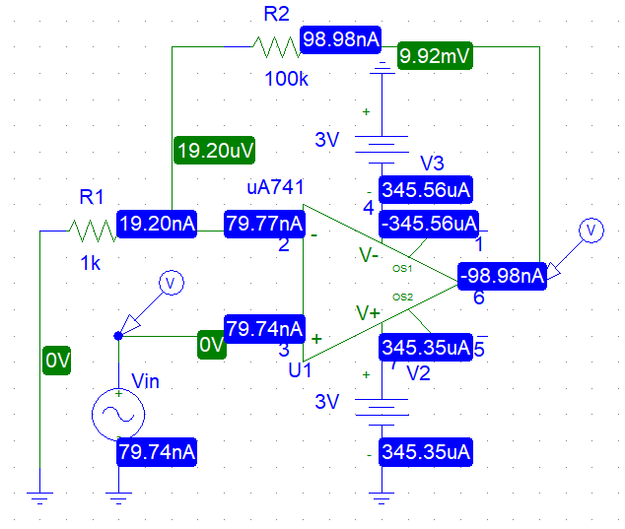

**Figure 4: Circuit simulation in PSpice.**



**Figure 4: Generated graph for figure 4 circuit simulation in PSpice.**

Here green line is input function and the red line is for output function. It is clear that we are able to convert a sinusoidal wave to a square wave. Both of the functions are in same frequency.

**Experiment:**

**Discussion:**

This project experiment is carried out both in a physical laboratory and virtually utilizing PSpice simulation. Because the magnitudes were not interrupted in PSpice, the trials were considerably easier to carry out. As a result, the predicted and experimental values were similar. However, while the experiment was carried out physically, there was some discrepancy.

After this project we are able to convert a sine wave into a square wave. There are many combinations of circuit to do this project. Here we only used the non-inverting theory with a normal operational amplifier. In our process there is two important thing we need to execute. Our circuit need to performed in higher gain and the output voltage must be greater than bias voltage. After doing this all we are able to make a square function.